38.10: 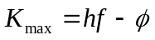
Use the information given for 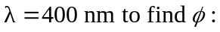
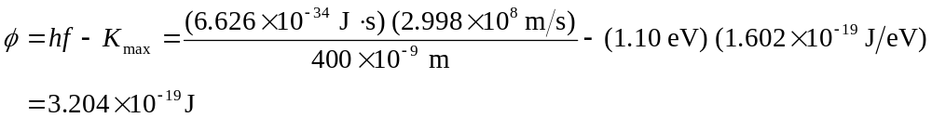
Now calculate 